**Name: Areeba Usman**

**Sapid: 49039**

**Lab # 3:**

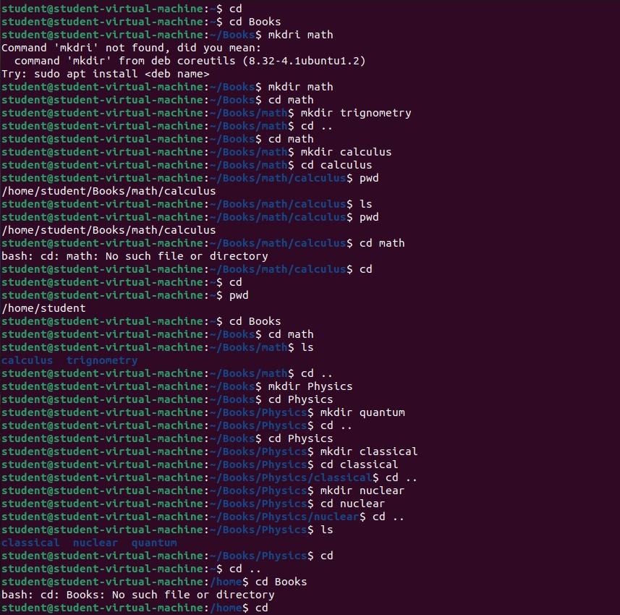

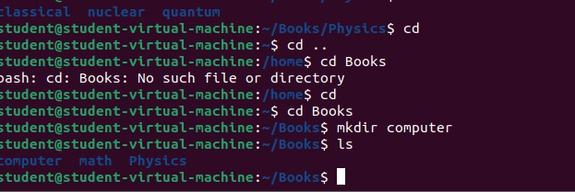

**Lab task 1:**

**1)**Create other directory chemistry under books, and move to chemistry directory.

Now you are quite away from your home directory. How would you go to your home directory directly?

Your current location is:

 books  chemistry Go to Home directory directly.

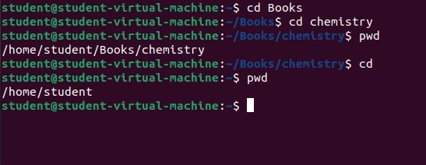

**Lab task 2:**

**2)**Now you are in your home directory. How will you go to chemistry directory directly?

What do you think **books/chemistry** is relative or absolute path?

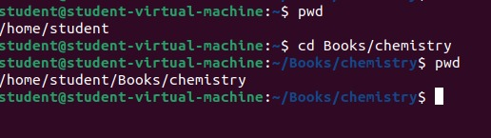

"Books/chemistry" would be considered a relative path because it describes a location relative to the current working directory, meaning it doesn't specify the full path from the root directory.

**Lab task 3:**

**3)**How will you add a directory **graphics** under the directory computer while you are in **physics** ’subdirectory **classical**?

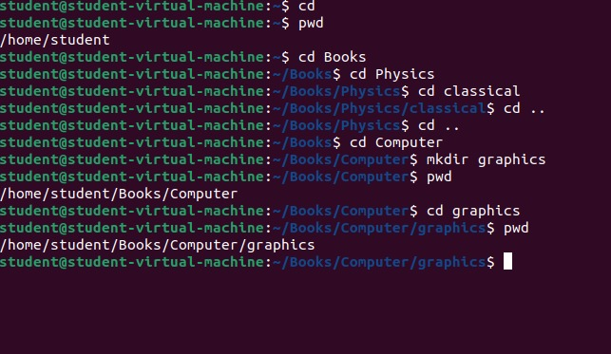

**Lab task 4:**

**4)**You are in books directory, from here try to remove sub-directory quantum under the directory physics.

Now move to directory computer, from here remove sub-directory calculus under the directory math.

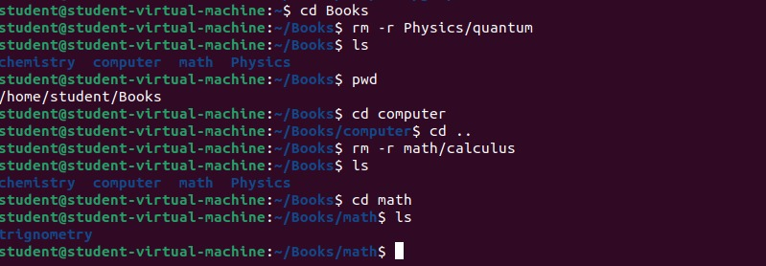

**Lab task 5:**

**5)**Which are the Linux Directory Commands? Explain the understanding of commands in your own words.

**Pwd (Print Working Directory)**

* This command shows the current directory you are in.

**ls (List Directory)**

* It displays the files and directories inside the current directory.

**ls -l →** Shows detailed information (permissions, owner, size, date modified).

**ls -a →** Displays hidden files.

**cd (Change Directory)**

* It allows you to move between directories.

cd .. → Move one level up.

cd / → Go to the root directory.

**mkdir (Make Directory)**

* Used to create new directories (folders).

**rmdir (Remove Directory)**

* Deletes an empty directory.

**rm –r (Remove Directory and Files)**

* Used to delete a directory along with its contents.